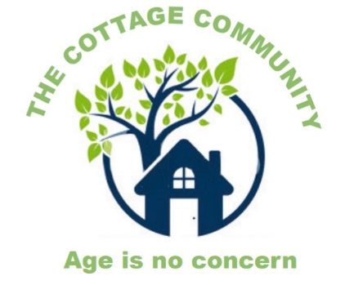
Day
Trips

Do you live in Swanley, DA3 or DA4 or West Kingsdown?
Are you over 55?
Do you live in the Rural Community?
If you would like to attend the following trips, please call
01322 668106
Wednesday 22nd September –Bluewater Shopping Centre (£8)
Friday 24th September – Hawley Craft Show (£8)
Wednesday 29th September – Sevenoaks Town Centre (£8)
Friday 1st October – Millbrook Garden Centre (£8)
Wednesday 6th October – Cream Tea at Redlibbets Golf Club (£16)
Friday 8th October Gravesend Cinema (£13 inc: £5 ticket)
Wednesday 13th October - Papa’s Barn Restaurant (£8)
Friday 15th October – Coolings Garden Centre (£8)
Wednesday 20th October – Bluewater Shopping Centre (£8)

The Cottage Community is a new independent charity (formally known as Rural Age Concern, Darent Valley). There is also a day centre for clients to have a hot 2 course lunch. Charity number: 1180662

